**Introduction to Linux**

**Student Name: Student Id:**

**Date:**

Please use the screenshots ONLY as a reference. The written instructions have to be followed AS written.

PLEASE MAKE SURE YOU SUBMIT ALL THE SCREENSHOTS WITH TIMESTAMPS AT THE BOTTOM RIGHT (WINDOWS USERS) OR THE TOP RIGHT (MAC OSX USERS) OR ELSE YOU WILL AUTOMATICALLY QUALIFY FOR A DISCOUNT.

# Objective:

A shell is a program that takes the command that we pass to it and it sends them to the operating system to be carried out. *The objective of this exercise is to help the student become familiar with using the shell. We will be using another application to interact with the shell called the “terminal”. We were given a brief introduction to the terminal in Exercise 1.*

**NOTE:**

* **There are 9 sections in this assignment, make sure you complete all of them in order. Some of the sections are dependent on earlier sections**
* **Code to be executed is highlighted in Green**
* **The explanation for all the code is provided below the code**
* **Maximize the terminal screen and increase the font to a visible size, otherwise points will be deducted**

Table of Contents

Objective: 1

Part-1: Introduction: 3

Part-2: Navigation: 5

Part-3: Basic Operations on Files: 7

Part-4: Working with Files and Directories: 8

Part-5: Finding Help: 12

Part-6: Input and Output: 14

Part-7: Using VI Editor: 16

Part-8: File Permissions: 19

Part-9: Checksum: 21

ADDITIONAL NOTES: 23

Part-1: Introduction: This section will give you a high-level overview of the shell, terminal, and some basic commands to get you started.

Step-1: Start the Cloudera VM and then launch the “terminal” application. The line that is highlighted in the screenshot below is called the shell prompt. The shell prompt appears whenever the shell is ready to accept commands. The shell prompt is usually in the format username@machinename.

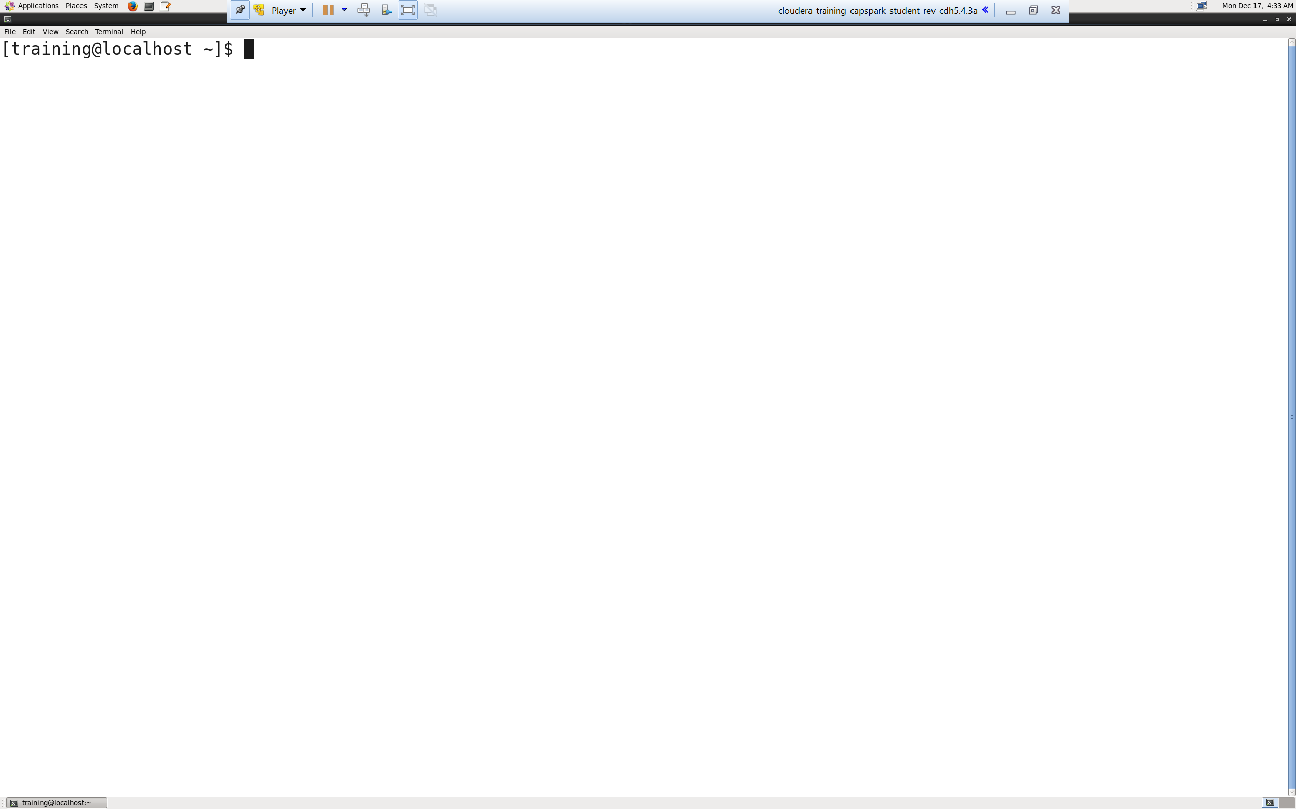

Q. Take a screenshot of the terminal highlighting the shell prompt and paste it below.

Step-2: Type some random letters into the shell prompt and execute.

Note: The shell will only recognize legitimate commands. For all other commands the terminal will output “command not found”

Q. Take a screenshot of the shell output and paste it below.

NOTES:

1. You may access previously used commands using the up/down arrows on your key board.

Step-3: Execute the following command at the shell prompt:



Q. Take a screenshot of the shell output and paste it below.

Explanation: The date command is used to output the current date and time to the console.

NOTES:

1. There are several simple commands that the shell provides, for example, date, cal etc.

Step-4: Execute the following command at the shell prompt:



Q. Take a screenshot of the shell output and paste it below.

Explanation: The clear command clears the terminal screen.

Part-2: Navigation: In this section we will learn how to navigate the file system on Linux. All files and folders are stored in what are knows as directories. For those of you that have not worked with Linux before, directories are essentially folders. So, a directory, may contain files, and/or other directories. Directories are case sensitive, and the first directory on the Unix system is called the root directory.

Step-5: Execute the following command at the shell prompt:



Q. Take a screenshot of the shell output and paste it below.

Explanation: “pwd” stands for print working directory. It is not uncommon to lose track of where we are in the file system. Using the “pwd” command tells us exactly where we are.

Step-6: Execute the following command at the shell prompt:



Q. Take a screenshot of the shell output and paste it below.

Explanation: The “ls” command is used to list all contents of a directory. This can be used in two ways;

1. “ls”: This will list all the contents of the current directory.
2. “ls *pathname*”: This will list all the contents of the pathname that was passed to the “ls” command.

NOTES:

1. “pathname” above is a specific path on the system.

Step-7: Execute the following command at the shell prompt:



Q. Now type the command and execute. Take a screenshot of the shell output and paste it below.

Step-8: Execute the following command at the shell prompt:



Q. Now type the command and execute. Take a screenshot of the shell output and paste it below.

Explanation: “cd” stands for change directory. It is used to change your current working directory to another directory. The pathname may be one of the following;

1. Absolute Pathname: Absolute pathnames are relative to the root directory. This is what we did in Q8.
2. Relative Pathname: Relative pathnames are relative to the current working directory. (i.e. Only directories contained in the current directory) This is what we did in Q7.

Syntax: “cd pathname”

NOTES:

1. “pathname” above is a specific path on the system.

Part-3: Basic Operations on Files: In this section we will be working with files by executing various simple commands on files.

Step-9: Change directories by executing the following command at the shell prompt:



Now execute the following command at the shell prompt:



Q. Paste a screenshot of the shell output below.

Explanation: The “file” command is used to determine a files “type”.

Syntax: “file filename”

NOTES:

1. filename is the name of the file, whose type you wish to check

Step-10: From the same directory execute the following command:



Q. Take a screenshot of the shell output and paste it below.

Explanation: The “less” command is used to view the contents of a text file. To exit the “less” program enter the letter “q”.

Part-4: Working with Files and Directories: In this section we will take a look at some of the most commonly used commands that are used to make changes to files and directories.

Step-11: In the same directory, execute the following command at the shell prompt:



Q. Now type the command and execute. Take a screenshot of the shell output, highlight the directory and paste it below.

Explanation: *mkdir* is short for make directory. This command creates a new directory with the name that you have provided for it, in the current directory.

NOTES:

1. Replace FirstName and LastName with your first name and last name, DO NOT copy as is.

Syntax: mkdir “directory name”

Step-12: Execute the following command:



Now use the “cd” command to change directories to the directory you created in Step 11. Execute the following command:



Q. Now type the command and execute. Take a screenshot of the shell output and paste it below.

Explanation: “cp” stands for copy. The “cp” command is used to copy a file or directory from one location to another.

NOTES:

1. Replace FirstName and LastName with your first name and last name, DO NOT copy as is.

Syntax: “cp source(file/directory) destination(directory)”

Step-13: Execute the following command at the shell prompt:



Q. Now type the command and execute. Take a screenshot of the shell output and paste it below. What do you see?

Step-14: Execute the following command at the shell prompt:



Execute the following command to do so:



Q. Now type the command and execute. Take a screenshot of the shell output and paste it below. Look for the file that you renamed in the previous step. Highlight this file in the screenshot.

Explanation: “mv” stand for move. The “mv” command has 2 purposes, they are as follows:

* 1. Move a file from one location to another
  2. Rename the file

The “cd” command provided above is to change directories to the parent directory. Alternatively, you may also use the entire pathname of the parent directory.

NOTES:

1. Replace FirstName and LastName with your first name and last name, DO NOT copy as is.
2. We have done both, we moved the file to a new directory and we also changed the name.

Syntax: “mv filename destination_pathname”

Step-15: Execute the following command:



You have to enter ‘y’ when prompted “remove regular file *filename*”

Now execute the following command next:



You have to enter ‘y’ when prompted “remove regular directory *directoryName*”



Q. Now type the command and execute. Take a screenshot of the shell output and paste it below. What changes do you see after you executed the commands in this step?

Explanation: “rm” stands for remove. The “rm” command is used to remove files and directories. You will always be prompted to confirm deletion of anything that you are deleting. Be sure before you delete a file because there is no recycle bin or trash, that files go to when they are deleted. Once they are deleted, that is **final**.

Syntax:

For files: “rm filename”

For directories: “rm options directoryName”

NOTES:

1. There are various options that you can use with the rm command, browse Part-5 to see how to find these options.

Part-5: Finding Help: This section will cover how to get additional information about files and commands using the shell.

Step-16: Execute the following command at the shell prompt:



Q. Take a screenshot of the shell output and paste it below.

Explanation: The “type” command tells us what kind type of command, the command that we entered is. There are 4 types of commands, they are as follows:

1. An executable program
2. A command built in to the shell
3. Shell function
4. An Alias

Step-17: Execute the following command at the shell prompt:



Q. Take a screenshot of the shell output and paste it below.

Explanation: The “help” command accesses the documentation for the command we entered at the shell prompt.

Syntax: You may use any of the following syntax to get the documentation for a command:

1. “help command”
2. “command –help”
3. “man command”

NOTES:

1. “command” in the above statements is the actual command which you wish to find more information about. “man” in the third command stands for “manual”, it displays the commands formal documentation.

Step-18: Execute the following command at the shell prompt and execute:



Now enter this command at the shell prompt and execute:



Q. Take a screenshot of the shell output and paste it below. What do you see? What does the foo command do?

Explanation: The “alias” command is used to alias other commands. It is a very powerful tool, in this question we alias one command and a very small one, but we can use alias for very long and multiple commands.

NOTES:

1. The command that is being aliased should be kept in single quotes, in this case ‘ls”

Part-6: Input and Output: In this section we will cover a very useful feature called IO redirection. IO redirection is used to redirect input/output to and from files.

Step-19: Execute the following command:



Now to view the contents of the text file we just created use the following command:



Q. Take a screenshot of the shell output and paste it below and paste it below.

Explanation: Using the ‘>’ character after a legal command that has an output will redirect that output to the filename that you specified.

NOTES: Be careful of the following when using the “>” re-direction operator.

1. There is also an ‘>>’ re-direction operator. But the difference is that ‘>>’ is for appending to a text file, while ‘>’ is for creating/overwriting a text file and writing the contents to that file
2. Error Messages will not be redirected, only outputs from a legal command will be redirected
3. Be careful when redirecting output to a text file, using the same filename more than once with the ‘>’ operator will overwrite the contents of the text file. In this case, you should use the ‘>>’ operator to append to the existing text file.
4. Replace FirstName and LastName with your first name and last name, DO NOT copy as is.

Syntax: “*command* > text_file_name”

Step-20: Execute the following command at the shell prompt:



Now, at the shell prompt type the following:

“My name is FirstName LastName, and I Love Linux”

Submit the text you entered by pressing the enter key then

Now enter the following command at the shell prompt:



NOTES:

1. Replace FirstName and LastName with your first name and last name, DO NOT copy as is.

Q. Take a screenshot of the shell output and paste it below.

Explanation: “cat” stands for concatenate. The “cat” command is used to redirect input. We may redirect input from files, user input to an output which may be files or standard output.

Step-21: Execute the following command at the shell prompt:



Q. Take a screenshot of the shell output and paste it below.

Explanation: “|” is called the pipe operator, and it is extremely useful in redirecting output to input. The output of the “ls” command is being sent to the input of the “less” command. As a result, a list of all your files and directories from your current working directory are listed.

Syntax: “command | command”

Part-7: Using VI Editor: There are several editors that are compatible with Linux, however for the purposes of this course we will be using VI editor, which is the basic editor for Linux. This section will provide a basic tutorial on how to use VI editor.

Step-22: Execute the following command at the shell prompt:



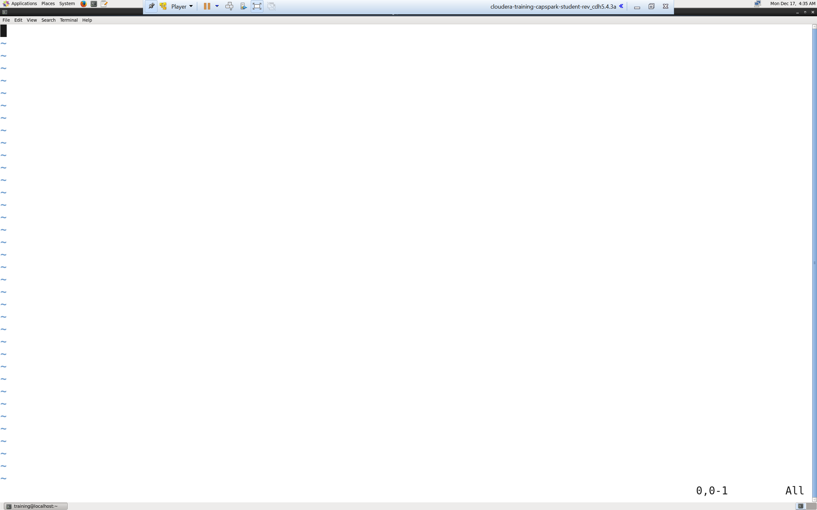You should see a screen, like the screenshot below.

Q. Take a screenshot of the vi editor and paste it below.

Explanation: Using the “vi” command starts the VI editor. If a file with the name you specify already exists, the VI application will open that file. If the name you specify does not exist, then VI will create a new file based on the name you provide.

NOTES:

1. Once the VI editor opens up, you should see a cursor, followed by a ‘~’ at the top as shown in the screenshot. There is also a status line at the bottom that provides information and feedback, this is also highlighted in the screenshot above.

Step-23: Try typing something in the editor.

Q. Are you able to type anything in the editor?

Explanation: VI editor has several modes:

* Command Mode (default): This is the mode where commands are given to move around the file and make changes to the file.
* Insert Mode: This is the mode that is used to enter text.

Step-24: Enter insert mode by executing the following command (the letter i):



Now type in the following text:

“My name is FirstName and using VI editor is easy!”

NOTES:

1. Replace FirstName with your first name, DO NOT copy as is.

Step-25. Enter the following commands in the VI editor:



Explanation: To exit the VI editor we have to follow a specific sequence. We always have to go in to command mode, so hitting “esc” will always remain common. After you are in command mode you have the following options:

* ZZ (Write if there were changes then quit)
* :wq (Write then quit)
* :q (Quit, this will only work if the file has not been changed)
* :q! (Quit without making changes)

NOTES:

1. For those options that have a “:” you must hit return after entering those options. After you hit return/enter you will be returned to the shell prompt.

Step-26: Open the file you have just created by executing the following command:



Q. Take a screenshot of the text file in VI editor and paste it below.

Part-8: File Permissions: In Linux, each file and directory on the system is assigned access for the owner, groups of users, and everybody else. These rights can be assigned and modified, in this section we cover an example of access rights.

Step-27: Execute the following command at the shell prompt:



Enter the following command to enter Insert Mode:



Enter the following text into the VI editor:



Now, Enter the following commands to save and exit VI editor:



Q. Execute the following command at the shell prompt:



Take a screenshot of the contents of the text file and paste it below.

Explanation:

Line 1: This line is called the shebang, the shebang is used to indicate which program to use to interpret the script.

Line 2: The echo command prints the argument in the double quotes to the terminal.

NOTES:

1. Replace FirstName and LastName with your first name and last name, DO NOT copy as is.

Step-28: Try executing the script file you just created by executing the following command at the shell prompt:



Q. Take a screenshot of the shell output and paste it below. Why can’t you execute this file?

Explanation: We are trying to execute the script file we created in Step-27.

NOTES:

1. Replace FirstName and LastName with your first name and last name, DO NOT copy as is.

Step-29: Execute the following command at the shell prompt:



Q. Take a screenshot of the shell output and paste it below.

Explanation: ‘chmod’ stands for change file mode bits, we use it to change the level of access we have to the file. 755 gives us execute permissions to the file.

NOTES:

1. Replace FirstName and LastName with your first name and last name, DO NOT copy as is.

Part-9: Checksum: In this section we will perform a checksum

Step-30: Download the Checksum.zip file from eLearning in to the downloads folder **IN** the Cloudera VM using Mozilla Firefox.

Step-31: Execute the following command:



Q. Now type the command and execute. Take a screenshot of the shell output, highlight the zip file and paste it below.

Step-32: Execute the following command at the shell prompt:



Q. Now type the command and execute. Take a screenshot of the shell output, highlight the contents of the zip file and paste it below.

Explanation: The “unzip” command unzips the zip file.

Step-33: Execute the following command at the shell prompt:

Then execute the following command:

Q. Take a screenshot of the shell output and paste it below.

Step-34: Execute the following command at the shell prompt:





Q. Now type the command and execute. Take a screenshot of the shell output and paste it below.

# ADDITIONAL NOTES:

* Make sure to check the spelling before you execute a command, a spelling mistake in one step can snowball and prevent other steps from working.
* Execute means, type in the given command and hit return/enter
* Shell output refers to the output that you see in the terminal application after executing a command
* **SUBMIT A WORD DOCUMENT CONTAINING YOUR SCREENSHOTS IN ELEARNING**
* **Also submit the Checksum value (32-bit alpha numeric key) from Step-33 in the comments section of the submission as shown in the screenshot below:**

